Want to learn more? Here are few suggested resources:

Blessed: Experiencing the Promise of the Book of Revelation, by Nancy Guthrie (2022).
This is a popular level book exploring the main themes of the book of Revelation and taking special care to explore how these themes encourage our life.

Revelation: A Shorter Commentary, by G.K. (Greg) Beale (2015).
This “shorter” commentary is still 500+ pages but he writes in a way that is accessible to serious Bible students. If you are looking for a verse-by-verse approach, this is what you want. It is a bit pricey but worth it! If you are super ambitious, you could get his longer commentary which clocks in at 1309 pages! Anything from Greg Beale is worthwhile.

Videos: scan QR code with your smartphone camera

Bible Project Video #1 | Bible Project Video #2

“The seventy-two returned with joy, saying, “Lord, even the demons are subject to us in your name!” And he said to them, “I saw Satan fall like lightning from heaven. Behold, I have given you authority to tread on serpents and scorpions, and over all the power of the enemy, and nothing shall hurt you. Nevertheless, do not rejoice in this, that the spirits are subject to you, but rejoice that your names are written in heaven.”” (Luke 10:17–20)

“Then I saw an angel coming down from heaven, holding in his hand the key to the bottomless pit and a great chain. And he seized the dragon, that ancient serpent, who is the devil and Satan, and bound him for a thousand years, and threw him into the pit, and shut it and sealed it over him, so that he might not deceive the nations any longer, until the thousand years were ended. After that he must be released for a little while.” (Revelation 20:1–3)

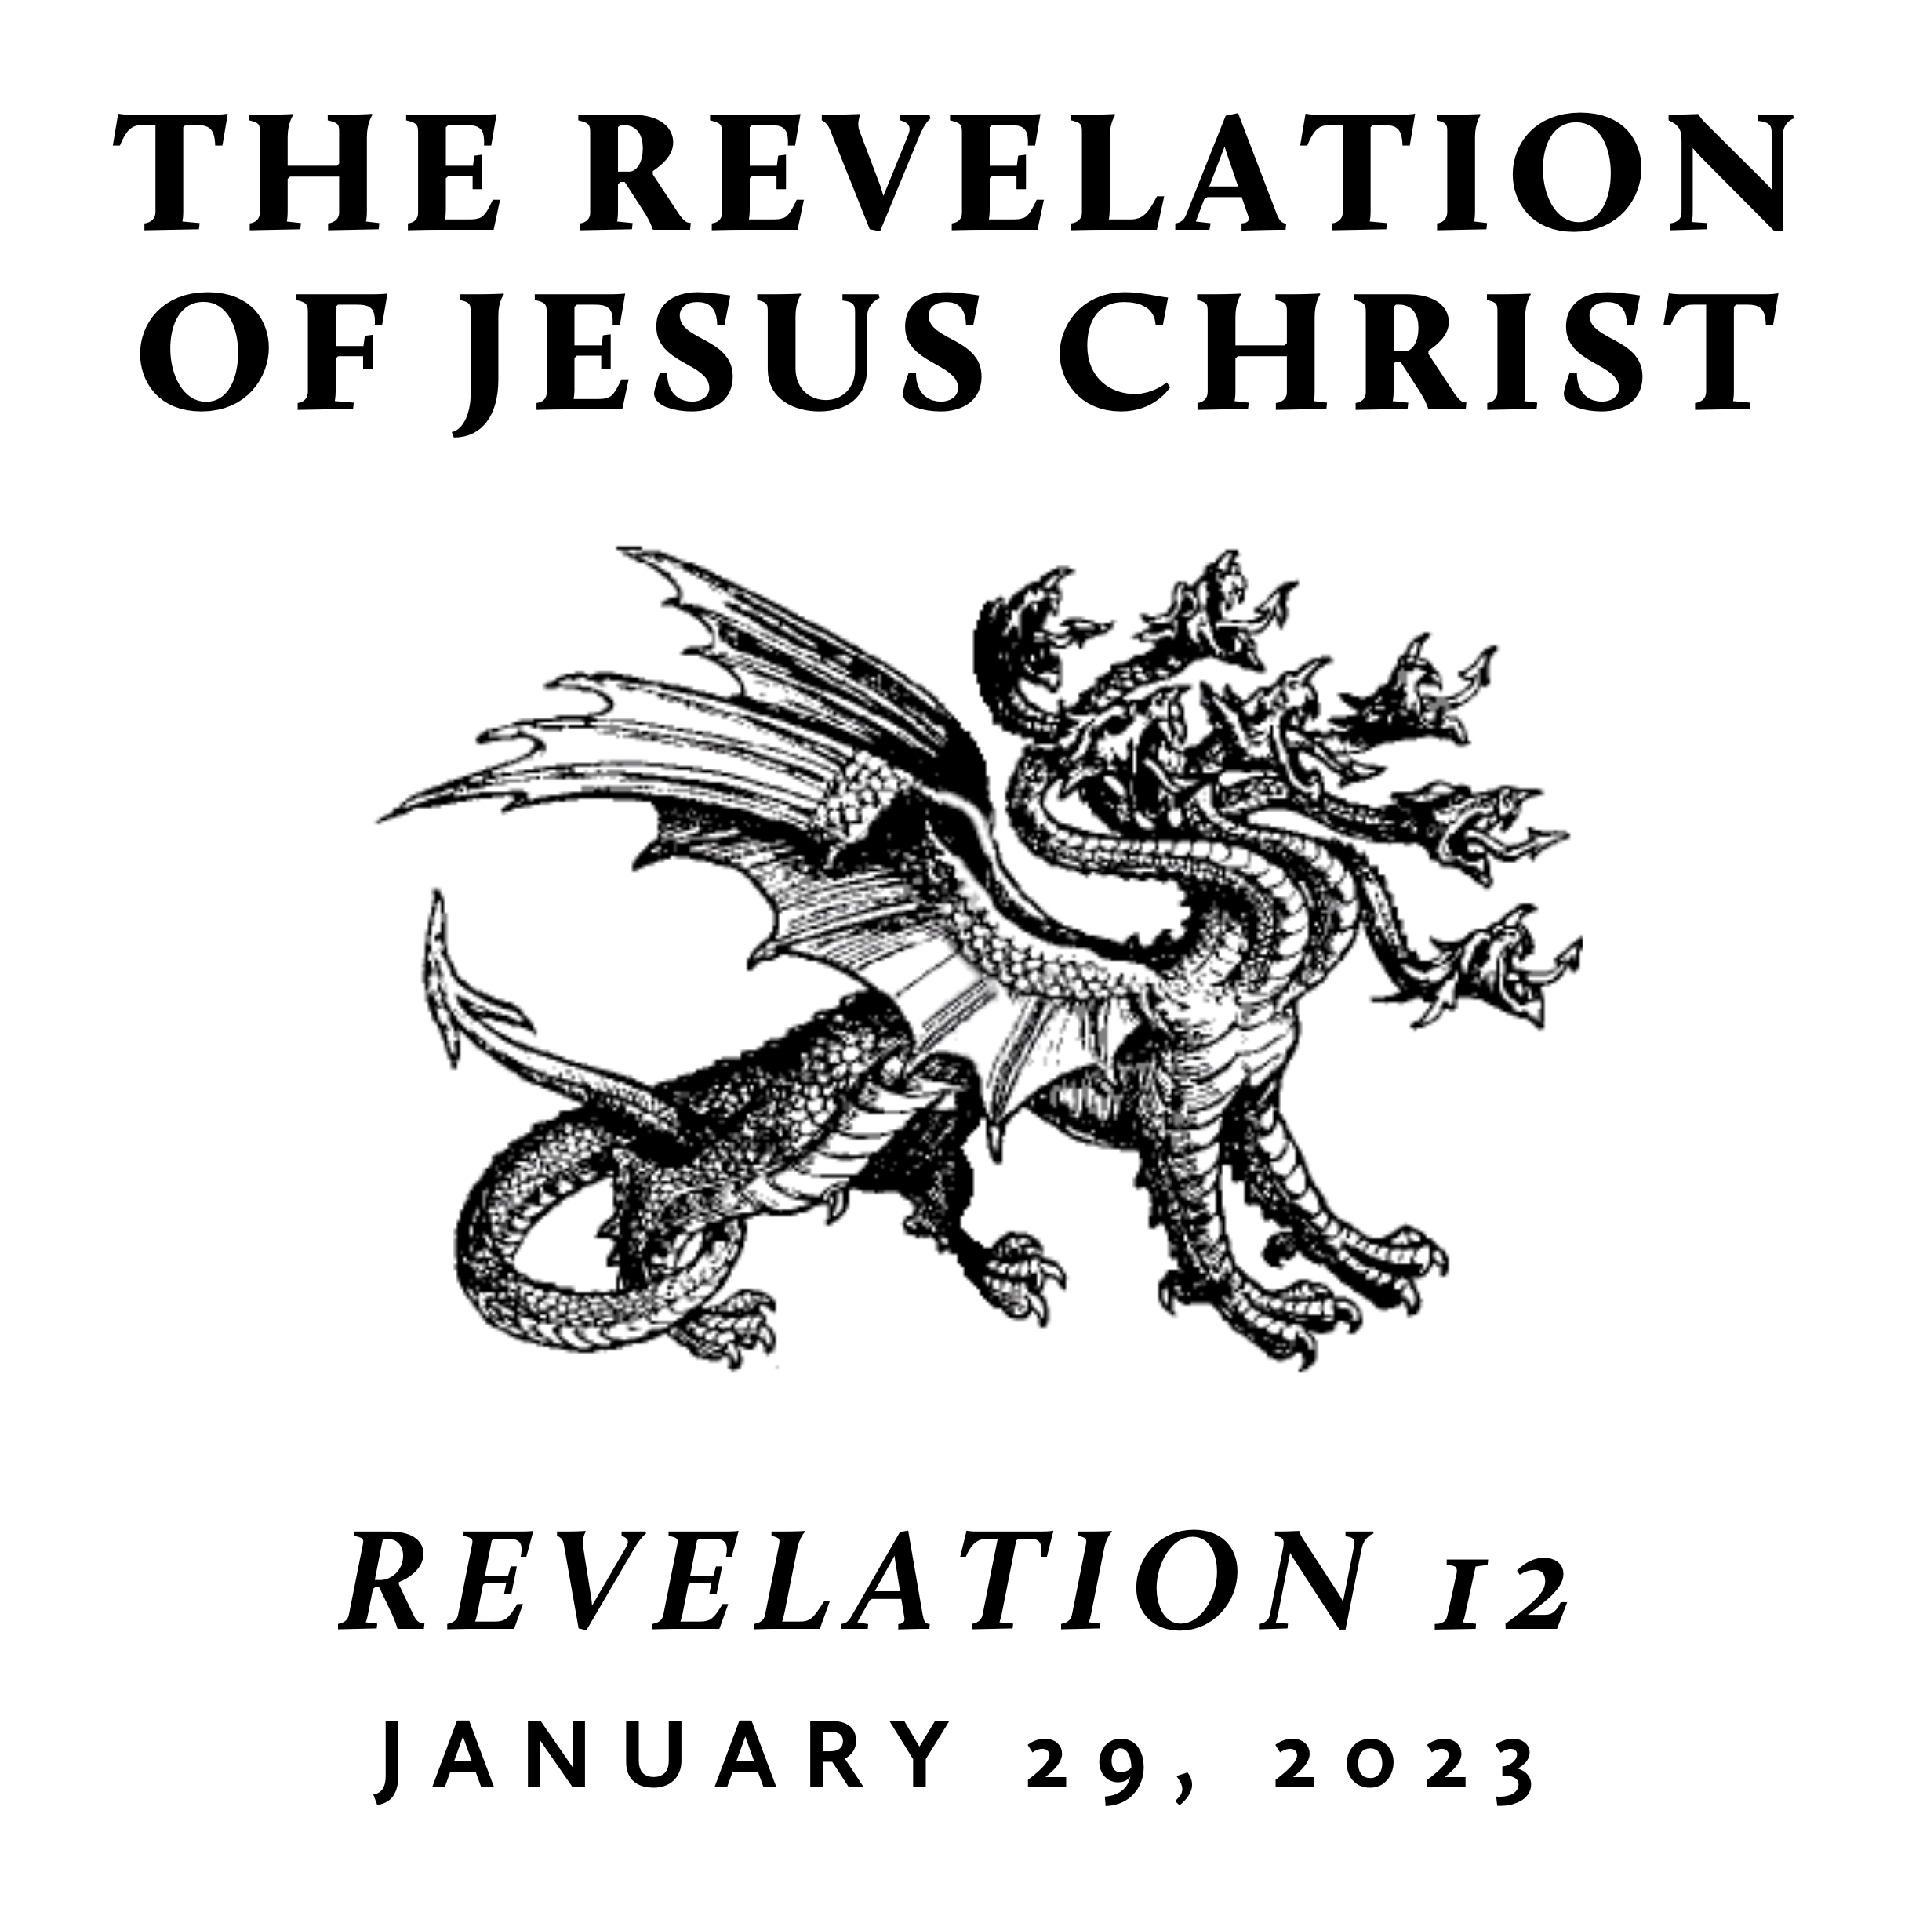

Winter 2023
Revelation is the last book of the Bible and is often treated as “mysterious” and “futuristic.” However, we contend that it only seems mysterious because it is full of images rooted in the Old Testament and first century Roman culture—from which we are far removed. A patient and careful reading yields an understanding that is neither bizarre nor exclusively future. Rather, we find the book of Revelation to be presently encouraging and empowering for the people of God. This is because it reveals heaven’s view of events that transpire on earth throughout history—including our history and the history of its original audience.

Conquering the Defeated Dragon
January 29, 2023 | Revelation 12:7–17 | Pastor Taylor Bradbury

Although the dragon has been decisively defeated by the work of Jesus, he is still intent on the harm of Jesus’ followers.

Revelation 12
¹ And a great sign appeared in heaven: a woman clothed with the sun, with the moon under her feet, and on her head a crown of twelve stars. ² She was pregnant and was crying out in birth pains and the agony of giving birth. ³ And another sign appeared in heaven: behold, a great red dragon, with seven heads and ten horns, and on his heads seven diadems. ⁴ His tail swept down a third of the stars of heaven and cast them to the earth. And the dragon stood before the woman who was about to give birth, so that when she bore her child he might devour it. ⁵ She gave birth to a male child, one who is to rule all the nations with a rod of iron, but her child was caught up to God and to his throne, ⁶ and the woman fled into the wilderness, where she has a place prepared by God, in which she is to be nourished for 1,260 days.

⁷ Now war arose in heaven, Michael and his angels fighting against the dragon. And the dragon and his angels fought back, ⁸ but he was defeated, and there was no longer any place for them in heaven. ⁹ And the great dragon was thrown down, that ancient serpent, who is called the devil and Satan, the deceiver of the whole world—he was thrown down to the earth, and his angels were thrown down with him. ¹⁰ And I heard a loud voice in heaven, saying, “Now the salvation and the power and the kingdom of our God and the authority of his Christ have come, for the accuser of our brothers has been thrown down, who accuses them day and night before our God. ¹¹ And they have conquered him by the blood of the Lamb and by the word of their testimony, for they loved not their lives even unto death. ¹² Therefore, rejoice, O heavens and you who dwell in them! But woe to you, O earth and sea, for the devil has come down to you in great wrath, because he knows that his time is short!”

¹³ And when the dragon saw that he had been thrown down to the earth, he pursued the woman who had given birth to the male child. ¹⁴ But the woman was given the two wings of the great eagle so that she might fly from the serpent into the wilderness, to the place where she is to be nourished for a time, and times, and half a time. ¹⁵ The serpent poured water like a river out of his mouth after the woman, to sweep her away with a flood. ¹⁶ But the earth came to the help of the woman, and the earth opened its mouth and swallowed the river that the dragon had poured from his mouth. ¹⁷ Then the dragon became furious with the woman and went off to make war on the rest of her offspring, on those who keep the commandments of God and hold to the testimony of Jesus. And he stood on the sand of the sea.
---------------------------------------------

- The Dragon has been defeated (7–12)
“God made us alive together with him, having forgiven us all our trespasses, by canceling the record of debt that stood against us with its legal demands. This he set aside, nailing it to the cross. He disarmed the rulers and authorities and put them to open shame, by triumphing over them in him.” (Colossians 2:13–15)

“The reason the Son of God appeared was to destroy the works of the devil.” (1 John 3:8)

- The Dragon still attacks the Church (13–17)
Thomas Watson: Our murmuring is the Devil’s music.

- The Dragon continues to be overcome through the blood of the Lamb and the word of our testimony (11)
“He who did not spare his own Son but gave him up for us all, how will he not also with him graciously give us all things? Who shall bring any charge against God’s elect? It is God who justifies. Who is to condemn? Christ Jesus is the one who died—more than that, who was raised—who is at the right hand of God, who indeed is interceding for us. Who shall separate us from the love of Christ? Shall tribulation, or distress, or persecution, or famine, or nakedness, or danger, or sword?” (Romans 8:32–35)

