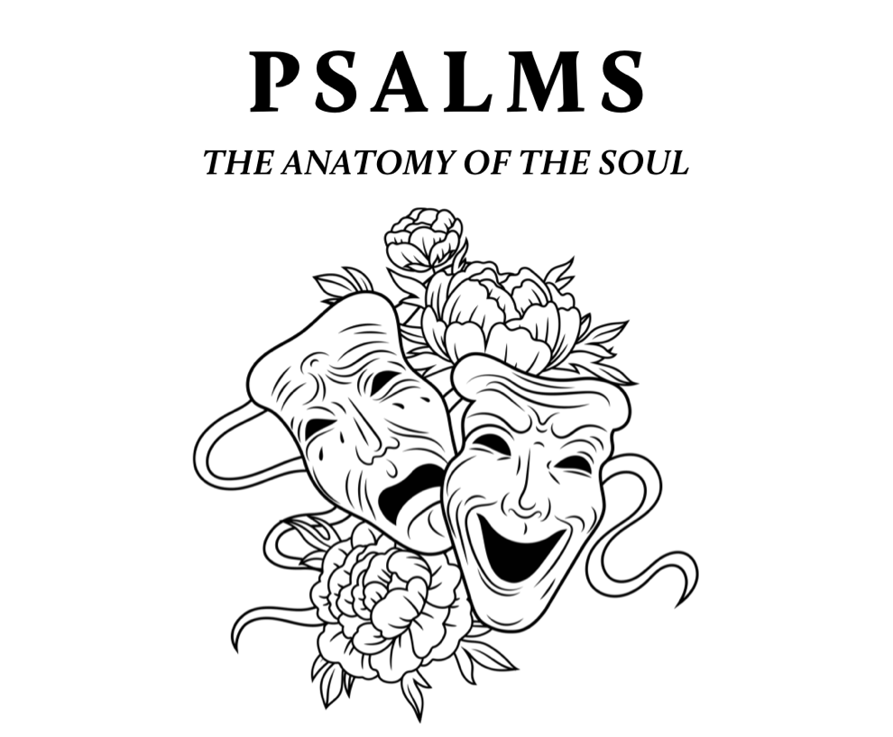
3. Glory Regained: in Jesus, a life of glory returns

Psalm 3 A Psalm of David, when he fled from Absalom his son.
¹ O Lord, how many are my foes!
Many are rising against me;
² many are saying of my soul,
“There is no salvation for him in God.” Selah
³ But you, O Lord, are a shield about me,
my glory, and the lifter of my head.
⁴ I cried aloud to the Lord,
and he answered me from his holy hill. Selah
⁵ I lay down and slept;
I woke again, for the Lord sustained me.
⁶ I will not be afraid of many thousands of people
who have set themselves against me all around.

John 1
¹ In the beginning was the Word, and the Word was with God, and the Word was God. ² He was in the beginning with God. ³ All things were made through him, and without him was not any thing made that was made. ⁴ In him was life, and the life was the light of men. ⁵ The light shines in the darkness, and the darkness has not overcome it….¹⁴ And the Word became flesh and dwelt among us, and we have seen his glory, glory as of the only Son from the Father, full of grace and truth
John 20
²⁰ “I do not ask for these only, but also for those who will believe in me through their word, ²¹ that they may all be one, just as you, Father, are in me, and I in you, that they also may be in us, so that the world may believe that you have sent me. ²² The glory that you have given me I have given to them, that they may be one even as we are one, ²³ I in them and you in me, that they may become perfectly one, so that the world may know that you sent me and loved them even as you loved me.
--------

The promise of glory is the promise, almost incredible and only possible by the work of Christ, that some of us, that any of us who really chooses, shall actually survive that examination, shall find approval, shall please God. To please God…to be a real ingredient in the divine happiness…to be loved by God, not merely pitied, but delighted in as an artist delights in his work or a father in a son—it seems impossible, a weight or burden of glory which our thoughts can hardly sustain. But so it is.
- C.S. Lewis, The Weight of Glory

PSALM 62
(part 2)
SEPTEMBER 3, 2023
New City is spending time this summer exploring the Psalms – the songbook given by God to his people for worship, community, and a hopeful realism. This was modeled well in the life of Jesus. Though separated by language, culture, and generations, the Psalms are still the inspired and reliable guide to our own hearts and a constant help in honestly navigating the chaos of our world with God-honoring, Christ-centered, hope-filled resiliency.

Theologian John Calvin called the Psalms an “anatomy of the soul.” By this he meant that, in the Psalms, we find a study of the innerworkings of the emotional life of each person. Join us as we let the Bible expose, encourage, shape, and renew us through this songbook of ancient and eternal wisdom.
Psalm 62
To the choirmaster: according to Jeduthun. A Psalm of David.
¹ For God alone my soul waits in silence;
from him comes my salvation.
² He alone is my rock and my salvation,
my fortress; I shall not be greatly shaken.
³ How long will all of you attack a man to batter him,
like a leaning wall, a tottering fence?
⁴ They only plan to thrust him down from his high position.
They take pleasure in falsehood.
They bless with their mouths,
but inwardly they curse. Selah
⁵ For God alone, O my soul, wait in silence,
for my hope is from him.
⁶ He only is my rock and my salvation,
my fortress; I shall not be shaken.
⁷ On God rests my salvation and my glory;
my mighty rock, my refuge is God.
⁸ Trust in him at all times, O people;
pour out your heart before him;
God is a refuge for us. Selah
⁹ Those of low estate are but a breath;
those of high estate are a delusion;
in the balances they go up;
they are together lighter than a breath.
¹⁰ Put no trust in extortion;
set no vain hopes on robbery;
if riches increase, set not your heart on them.
¹¹ Once God has spoken;
twice have I heard this:
that power belongs to God,
¹² and that to you, O Lord, belongs steadfast love.
For you will render to a man
according to his work.
On God Rests My Glory
September 3, 2023 | Psalm 62 (part 2) | Pastor Roger Williams

We are designed for glory that rests on God alone.

1. Glory: original design
Genesis 1
²⁶ Then God said, “Let us make man in our image, after our likeness. And let them have dominion over the fish of the sea and over the birds of the heavens and over the livestock and over all the earth and over every creeping thing that creeps on the earth.”
²⁷ So God created man in his own image,
in the image of God he created him;
male and female he created them.
²⁸ And God blessed them. And God said to them, “Be fruitful and multiply and fill the earth and subdue it, and have dominion over the fish of the sea and over the birds of the heavens and over every living thing that moves on the earth.”

Isaiah 40
¹¹ He will tend his flock like a shepherd;
he will gather the lambs in his arms;
he will carry them in his bosom,
and gently lead those that are with young.
¹² Who has measured the waters in the hollow of his hand
and marked off the heavens with a span…
¹⁵ Behold, the nations are like a drop from a bucket,
and are accounted as the dust on the scales;
behold, he takes up the coastlands like fine dust.

2. Glory Lost: disconnected, but hints of it everywhere
John 5
⁴⁴ How can you believe, when you receive glory from one another and do not seek the glory that comes from the only God?

