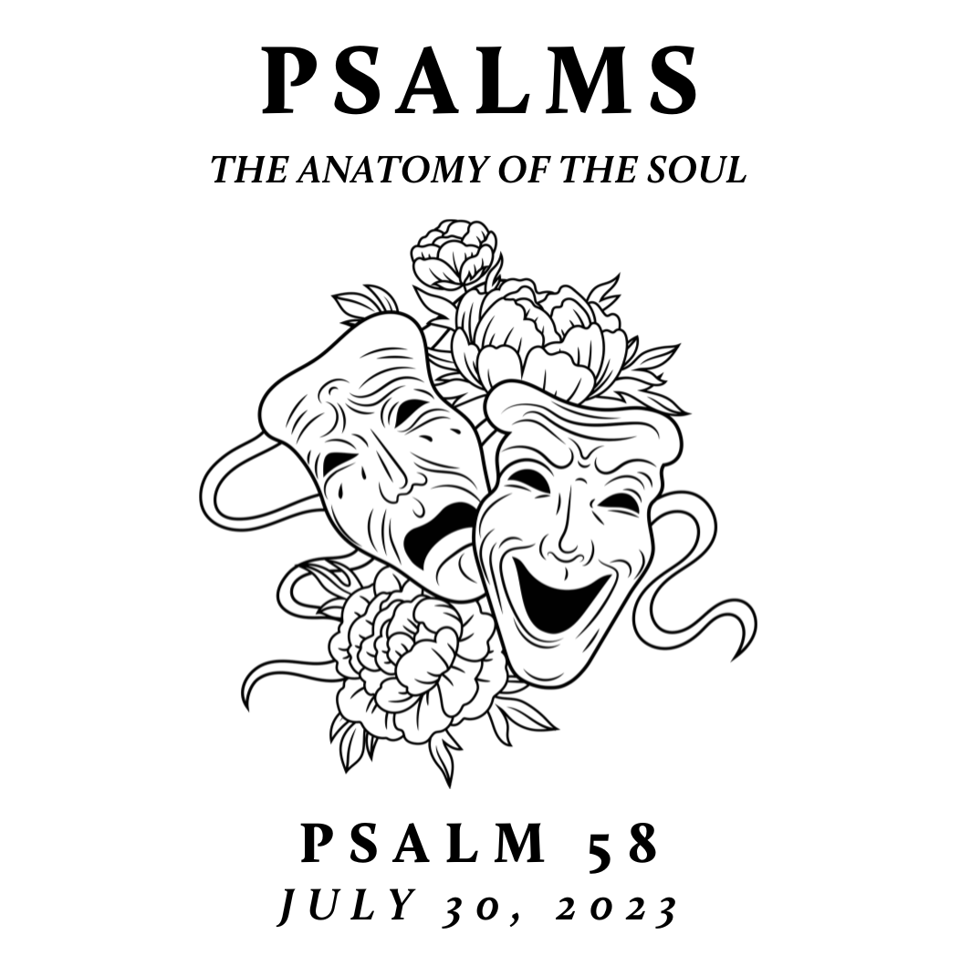

New City is spending time this summer exploring the Psalms – the songbook given by God to his people for worship, community, and a hopeful realism. This was modeled well in the life of Jesus. Though separated by language, culture, and generations, the Psalms are still the inspired and reliable guide to our own hearts and a constant help in honestly navigating the chaos of our world with God-honoring, Christ-centered, hope-filled resiliency

Rightly Requesting God’s Retribution
July 30, 2023 | Psalm 58 | Pastor Taylor Bradbury

Psalm 58

To the choirmaster: according to Do Not Destroy.
A Miktam of David.

¹ Do you indeed decree what is right, you gods?
Do you judge the children of man uprightly?
² No, in your hearts you devise wrongs;
your hands deal out violence on earth.

³ The wicked are estranged from the womb;
they go astray from birth, speaking lies.
⁴ They have venom like the venom of a serpent,
like the deaf adder that stops its ear,
⁵ so that it does not hear the voice of charmers
or of the cunning enchanter.

⁶ O God, break the teeth in their mouths;
tear out the fangs of the young lions, O Lord!
⁷ Let them vanish like water that runs away;
when he aims his arrows, let them be blunted.
⁸ Let them be like the snail that dissolves into slime,
like the stillborn child who never sees the sun.
⁹ Sooner than your pots can feel the heat of thorns,
whether green or ablaze, may he sweep them away!

¹⁰ The righteous will rejoice when he sees the vengeance;
he will bathe his feet in the blood of the wicked.
¹¹ Mankind will say, “Surely there is a reward for the righteous;
surely there is a God who judges on earth.”

Imprecatory prayer can be a useful tool for followers of Jesus in a world scarred by darkness, wickedness, and rebellion.

Notes:

Ephesians 6:10–20 – ¹⁰ Finally, be strong in the Lord and in the strength of his might. ¹¹ Put on the whole armor of God, that you may be able to stand against the schemes of the devil. ¹² For we do not wrestle against flesh and blood, but against the rulers, against the authorities, against the cosmic powers over this present darkness, against the spiritual forces of evil in the heavenly places. ¹³ Therefore take up the whole armor of God, that you may be able to withstand in the evil day, and having done all, to stand firm. ¹⁴ Stand therefore, having fastened on the belt of truth, and having put on the breastplate of righteousness, ¹⁵ and, as shoes for your feet, having put on the readiness given by the gospel of peace. ¹⁶ In all circumstances take up the shield of faith, with which you can extinguish all the flaming darts of the evil one; ¹⁷ and take the helmet of salvation, and the sword of the Spirit, which is the word of God, ¹⁸ praying at all times in the Spirit, with all prayer and supplication. To that end, keep alert with all perseverance, making supplication for all the saints, ¹⁹ and also for me, that words may be given to me in opening my mouth boldly to proclaim the mystery of the gospel, ²⁰ for which I am an ambassador in chains, that I may declare it boldly, as I ought to speak.

