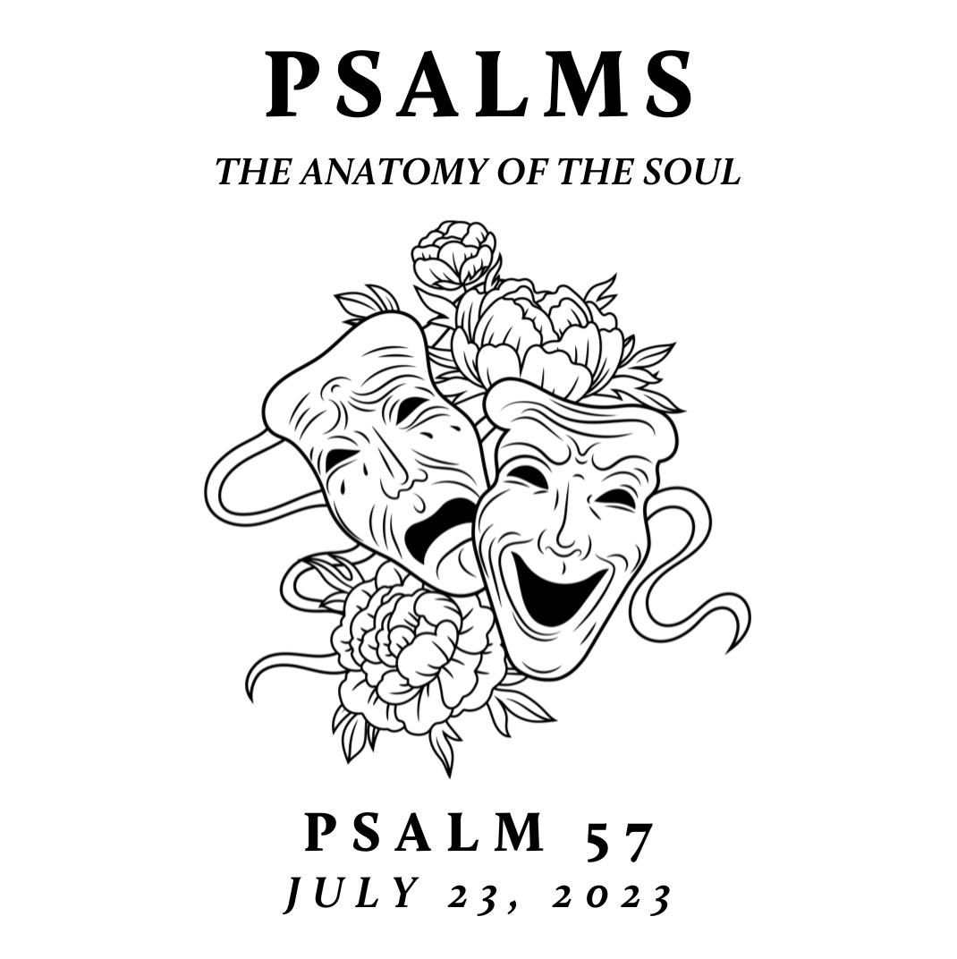

New City is spending time this summer exploring the Psalms – the songbook given by God to his people for worship, community, and a hopeful realism. This was modeled well in the life of Jesus. Though separated by language, culture, and generations, the Psalms are still the inspired and reliable guide to our own hearts and a constant help in honestly navigating the chaos of our world with God-honoring, Christ-centered, hope-filled resiliency

God’s Glory over all the Earth
July 23, 2023 | Psalm 57 | Pastor Taylor Bradbury

Psalm 57

To the choirmaster: according to Do Not Destroy.
A Miktam of David, when he fled from Saul, in the cave.

¹ Be merciful to me, O God, be merciful to me,
for in you my soul takes refuge;
in the shadow of your wings I will take refuge,
till the storms of destruction pass by.
² I cry out to God Most High,
to God who fulfills his purpose for me.
³ He will send from heaven and save me;
he will put to shame him who tramples on me. Selah
God will send out his steadfast love and his faithfulness!

⁴ My soul is in the midst of lions;
I lie down amid fiery beasts—
the children of man, whose teeth are spears and arrows,
whose tongues are sharp swords.

⁵ Be exalted, O God, above the heavens!
Let your glory be over all the earth!

⁶ They set a net for my steps;
my soul was bowed down.
They dug a pit in my way,
but they have fallen into it themselves. Selah
⁷ My heart is steadfast, O God,
my heart is steadfast!
I will sing and make melody!
⁸ Awake, my glory!
Awake, O harp and lyre!
I will awake the dawn!
⁹ I will give thanks to you, O Lord, among the peoples;
I will sing praises to you among the nations.
¹⁰ For your steadfast love is great to the heavens,
your faithfulness to the clouds.

¹¹ Be exalted, O God, above the heavens!
Let your glory be over all the earth!
Correct vision of God and His attributes can lead
those lamenting to confident praise.

Notes:

