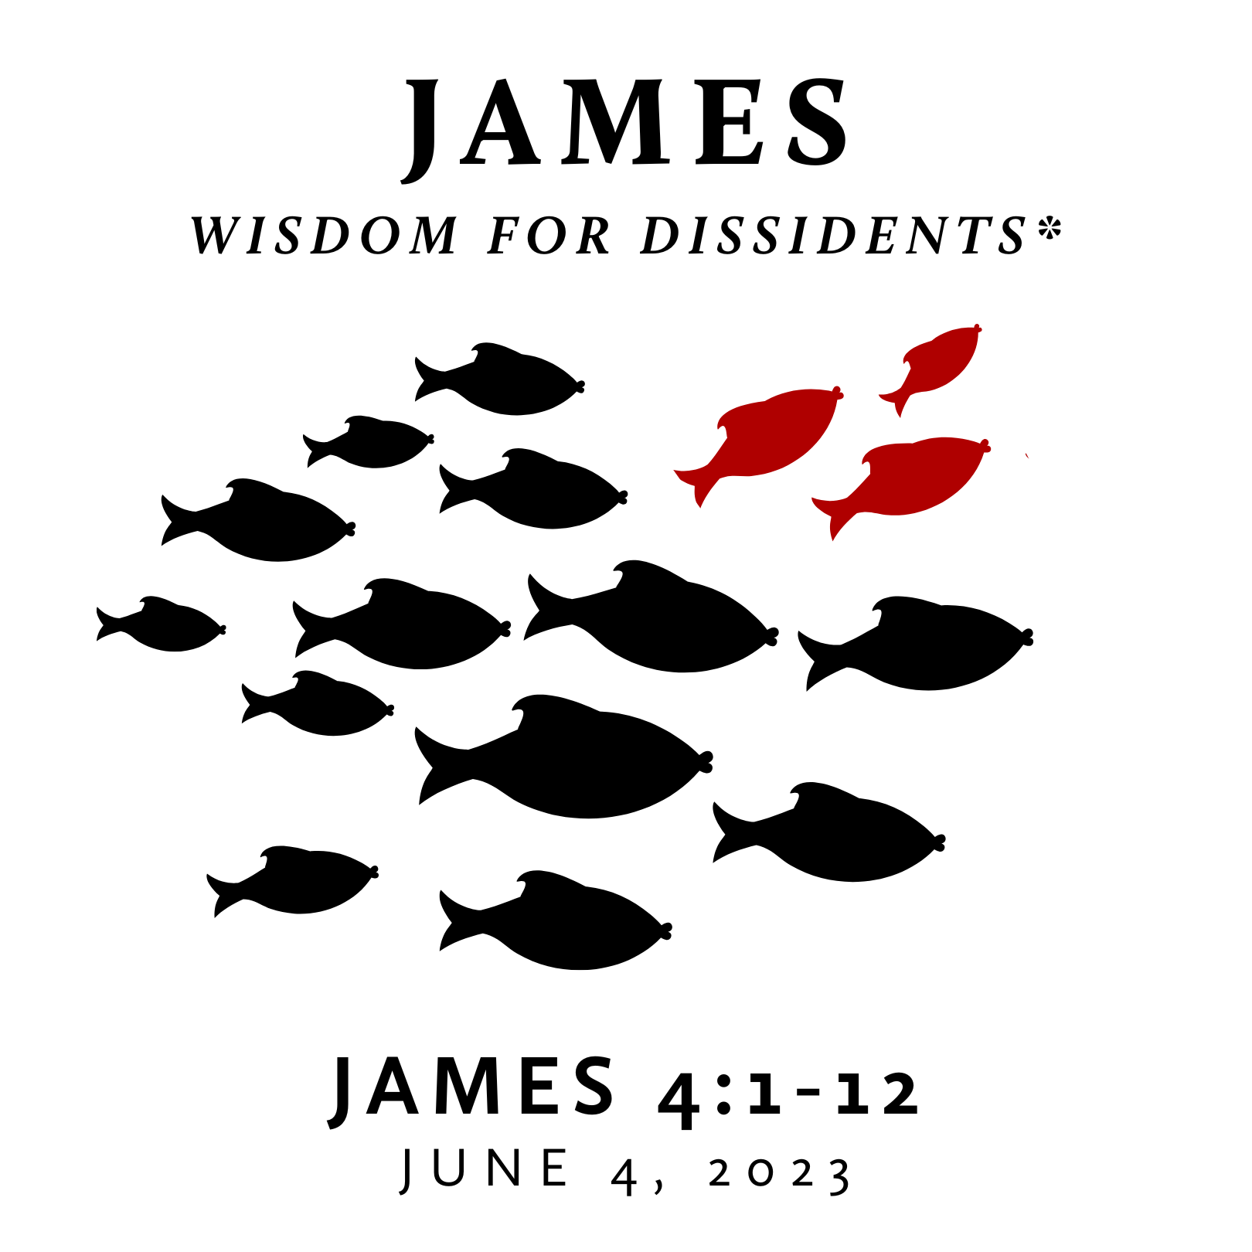

Spring/Summer 2023
The book of James is one of the earliest writings of the New Testament and given as wisdom to followers of Jesus who were facing severe trials. However, this wisdom does not align with the prevailing wisdom of any age. The Gospel of Jesus creates loving dissidents – those who dissent from the dominant way of being and, instead, live in step with the Kingdom of God. This dissent may be subtle or strong, but it is always a result of following Jesus in a culture committed to following many other things. Further, this type of wisdom pictures an alternate way of life for a world that desperately needs it. James is wisdom for such a life.
* This title is inspired by Pastor Jeff Meyers’ commentary with the same subtitle.

Spring/Summer 2023
The book of James is one of the earliest writings of the New Testament and given as wisdom to followers of Jesus who were facing severe trials. However, this wisdom does not align with the prevailing wisdom of any age. The Gospel of Jesus creates loving dissidents – those who dissent from the dominant way of being and, instead, live in step with the Kingdom of God. This dissent may be subtle or strong, but it is always a result of following Jesus in a culture committed to following many other things. Further, this type of wisdom pictures an alternate way of life for a world that desperately needs it. James is wisdom for such a life.
* This title is inspired by Pastor Jeff Meyers’ commentary with the same subtitle.

Worldliness in the Christian Life?
June 4, 2023 | James 4:1-12 | Pastor Taylor Bradbury

“Wisdoms” not from above produce fighting, worldliness,
and slander in the life of God’s people.

James 4:1-12
¹ What causes quarrels and what causes fights among you? Is it not this, that your passions are at war within you? ² You desire and do not have, so you murder. You covet and cannot obtain, so you fight and quarrel. You do not have, because you do not ask. ³ You ask and do not receive, because you ask wrongly, to spend it on your passions. ⁴ You adulterous people! Do you not know that friendship with the world is enmity with God? Therefore whoever wishes to be a friend of the world makes himself an enemy of God. ⁵ Or do you suppose it is to no purpose that the Scripture says, “He yearns jealously over the spirit that he has made to dwell in us”? ⁶ But he gives more grace. Therefore it says, “God opposes the proud but gives grace to the humble.” ⁷ Submit yourselves therefore to God. Resist the devil, and he will flee from you. ⁸ Draw near to God, and he will draw near to you. Cleanse your hands, you sinners, and purify your hearts, you double-minded. ⁹ Be wretched and mourn and weep. Let your laughter be turned to mourning and your joy to gloom. ¹⁰ Humble yourselves before the Lord, and he will exalt you.
¹¹ Do not speak evil against one another, brothers. The one who speaks against a brother or judges his brother, speaks evil against the law and judges the law. But if you judge the law, you are not a doer of the law but a judge. ¹² There is only one lawgiver and judge, he who is able to save and to destroy. But who are you to judge your neighbor?

Worldliness in the Christian Life?
June 4, 2023 | James 4:1-12 | Pastor Taylor Bradbury

“Wisdoms” not from above produce fighting, worldliness,
and slander in the life of God’s people.

James 4:1-12
¹ What causes quarrels and what causes fights among you? Is it not this, that your passions are at war within you? ² You desire and do not have, so you murder. You covet and cannot obtain, so you fight and quarrel. You do not have, because you do not ask. ³ You ask and do not receive, because you ask wrongly, to spend it on your passions. ⁴ You adulterous people! Do you not know that friendship with the world is enmity with God? Therefore whoever wishes to be a friend of the world makes himself an enemy of God. ⁵ Or do you suppose it is to no purpose that the Scripture says, “He yearns jealously over the spirit that he has made to dwell in us”? ⁶ But he gives more grace. Therefore it says, “God opposes the proud but gives grace to the humble.” ⁷ Submit yourselves therefore to God. Resist the devil, and he will flee from you. ⁸ Draw near to God, and he will draw near to you. Cleanse your hands, you sinners, and purify your hearts, you double-minded. ⁹ Be wretched and mourn and weep. Let your laughter be turned to mourning and your joy to gloom. ¹⁰ Humble yourselves before the Lord, and he will exalt you.
¹¹ Do not speak evil against one another, brothers. The one who speaks against a brother or judges his brother, speaks evil against the law and judges the law. But if you judge the law, you are not a doer of the law but a judge. ¹² There is only one lawgiver and judge, he who is able to save and to destroy. But who are you to judge your neighbor?

