Want to learn more? Here are few suggested resources:

Blessed: Experiencing the Promise of the Book of Revelation, by Nancy Guthrie (2022).
This is a popular level book exploring the main themes of the book of Revelation and taking special care to explore how these themes encourage our life.

Revelation: A Shorter Commentary, by G.K. (Greg) Beale (2015).
This “shorter” commentary is still 500+ pages but he writes in a way that is accessible to serious Bible students. If you are looking for a verse-by-verse approach, this is what you want. It is a bit pricey but worth it! If you are super ambitious, you could get his longer commentary which clocks in at 1309 pages! Anything from Greg Beale is worthwhile.

The Triumph of the Lamb, by Dennis Johnson (2001).
This is less verse-by-verse and more section-by-section. It is scholarly, but very readable. Johnson is a scholar/pastor and writes with the churchgoer in mind.

Videos: scan QR code with your smartphone camera

Bible Project Video #1 | Bible Project Video #2

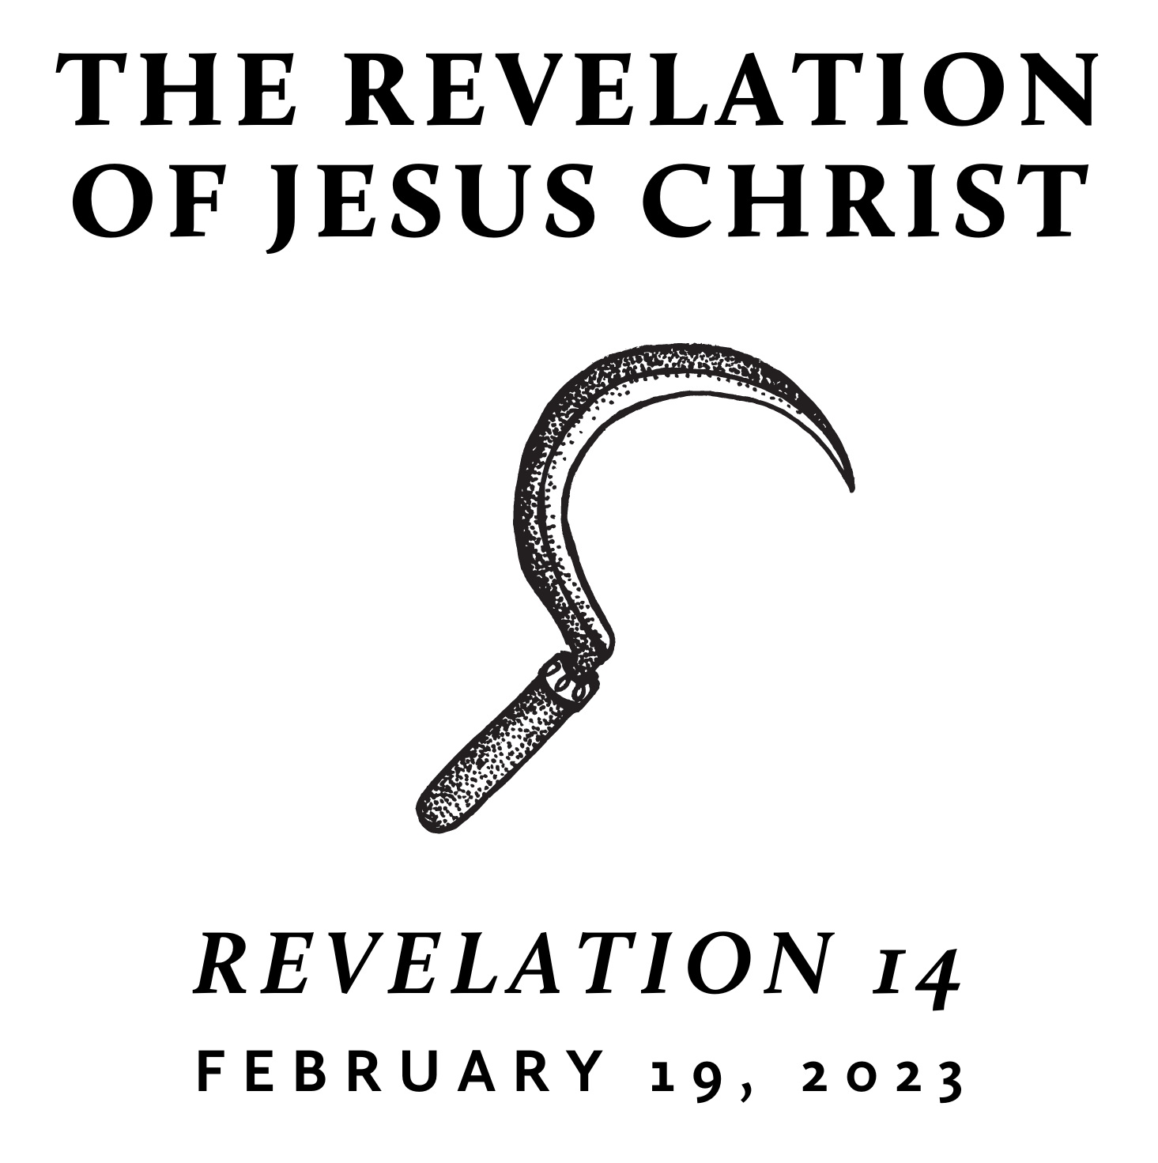

Fall/Winter 2022
Revelation is the last book of the Bible and is often treated as “mysterious” and “futuristic.” However, we contend that it only seems mysterious because it is full of images rooted in the Old Testament and first century Roman culture—from which we are far removed. A patient and careful reading yields an understanding that is neither bizarre nor exclusively future. Rather, we find the book of Revelation to be presently encouraging and empowering for the people of God. This is because it reveals heaven’s view of events that transpire on earth throughout history—including our history and the history of its original audience.

Which Mark Will You Choose?
February 19, 2023 | Revelation 14 | Pastor Taylor Bradbury

Revelation 14
¹ Then I looked, and behold, on Mount Zion stood the Lamb, and with him 144,000 who had his name and his Father's name written on their foreheads. ² And I heard a voice from heaven like the roar of many waters and like the sound of loud thunder. The voice I heard was like the sound of harpists playing on their harps, ³ and they were singing a new song before the throne and before the four living creatures and before the elders. No one could learn that song except the 144,000 who had been redeemed from the earth. ⁴ It is these who have not defiled themselves with women, for they are virgins. It is these who follow the Lamb wherever he goes. These have been redeemed from mankind as firstfruits for God and the Lamb, ⁵ and in their mouth no lie was found, for they are blameless.

⁶ Then I saw another angel flying directly overhead, with an eternal gospel to proclaim to those who dwell on earth, to every nation and tribe and language and people. ⁷ And he said with a loud voice, “Fear God and give him glory, because the hour of his judgment has come, and worship him who made heaven and earth, the sea and the springs of water.”

⁸ Another angel, a second, followed, saying, “Fallen, fallen is Babylon the great, she who made all nations drink the wine of the passion of her sexual immorality.”

⁹ And another angel, a third, followed them, saying with a loud voice, “If anyone worships the beast and its image and receives a mark on his forehead or on his hand, ¹⁰ he also will drink the wine of God's wrath, poured full strength into the cup of his anger, and he will be tormented with fire and sulfur in the presence of the holy angels and in the presence of the Lamb. ¹¹ And the smoke of their torment goes up forever and ever, and they have no rest, day or night, these worshipers of the beast and its image, and whoever receives the mark of its name.”

¹² Here is a call for the endurance of the saints, those who keep the commandments of God and their faith in Jesus.

¹³ And I heard a voice from heaven saying, “Write this: Blessed are the dead who die in the Lord from now on.” “Blessed indeed,” says the Spirit, “that they may rest from their labors, for their deeds follow them!”

¹⁴ Then I looked, and behold, a white cloud, and seated on the cloud one like a son of man, with a golden crown on his head, and a sharp sickle in his hand. ¹⁵ And another angel came out of the temple, calling with a loud voice to him who sat on the cloud, “Put in your sickle, and reap, for the hour to reap has come, for the harvest of the earth is fully ripe.” ¹⁶ So he who sat on the cloud swung his sickle across the earth, and the earth was reaped.

¹⁷ Then another angel came out of the temple in heaven, and he too had a sharp sickle. ¹⁸ And another angel came out from the altar, the angel who has authority over the fire, and he called with a loud voice to the one who had the sharp sickle, “Put in your sickle and gather the clusters from the vine of the earth, for its grapes are ripe.” ¹⁹ So the angel swung his sickle across the earth and gathered the grape harvest of the earth and threw it into the great winepress of the wrath of God. ²⁰ And the winepress was trodden outside the city, and blood flowed from the winepress, as high as a horse's bridle, for 1,600 stadia.

---------------------------------------------

Notes:

