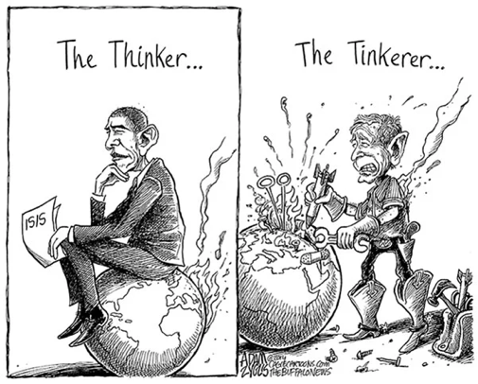

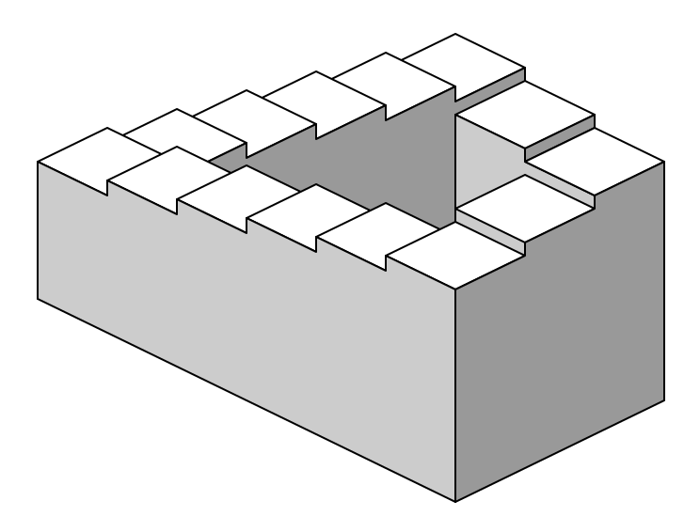
[The Trumpets] content suggests, among many other things, the plagues of Egypt which accompanied the exodus, the fall of Jericho to the army of Joshua, the army of locusts depicted in the prophecy of Joel, the Sinai theophany, the contemporary fear of invasion by Parthian cavalry, the earthquakes to which the cities of Asia Minor were rather frequently subject, and very possibly the eruption of Vesuvius which had recently terrified the Mediterranean world. [Revelation] has taken some of John’s contemporaries' worst experiences and worst fears of wars and natural disasters, blown them up to apocalyptic proportions, and cast them in biblically allusive terms. The point is not to predict a sequence of events. The point is to evoke and to explore the meaning of the divine judgment which is impending on the sinful world.
-Richard Bauckham, The Theology of the Book of Revelation, 20.

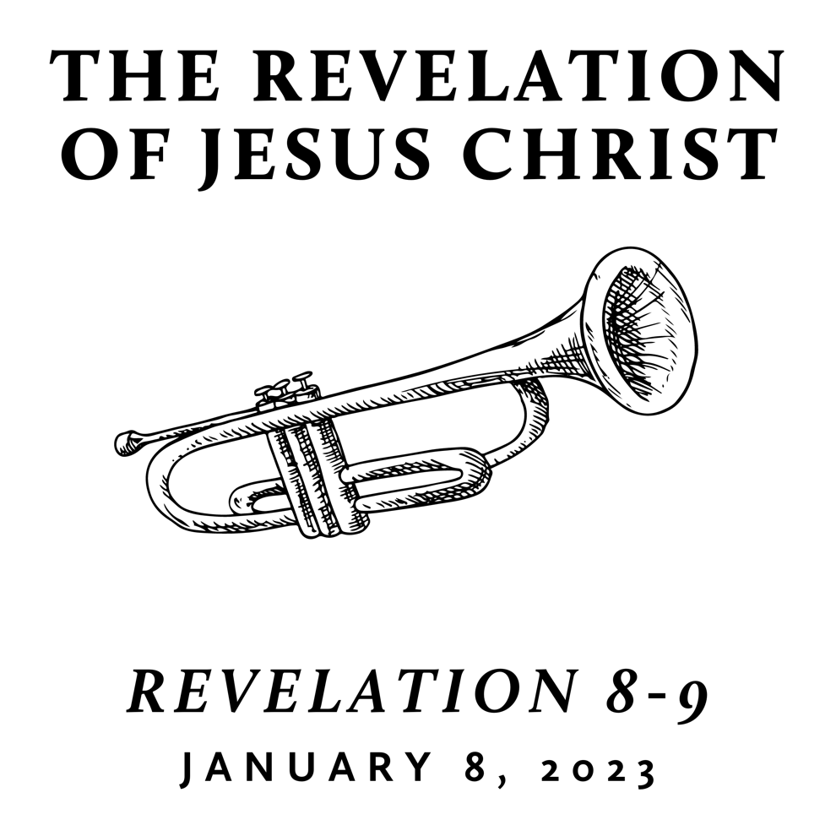

Winter 2023
Revelation is the last book of the Bible and is often treated as “mysterious” and “futuristic.” However, we contend that it only seems mysterious because it is full of images rooted in the Old Testament and first century Roman culture—from which we are far removed. A patient and careful reading yields an understanding that is neither bizarre nor exclusively future. Rather, we find the book of Revelation to be presently encouraging and empowering for the people of God. This is because it reveals heaven’s view of events that transpire on earth throughout history—including our history and the history of its original audience.
Warning and Witness
January 8, 2023 | Revelation 8-9 | Pastor Roger Williams
God’s activity in our world, even in warning, exposes the folly and destruction of sin and the goodness of life available in him.
Revelation 8 When the Lamb opened the seventh seal, there was silence in heaven for about half an hour. ² Then I saw the seven angels who stand before God, and seven trumpets were given to them. ³ And another angel came and stood at the altar with a golden censer, and he was given much incense to offer with the prayers of all the saints on the golden altar before the throne, ⁴ and the smoke of the incense, with the prayers of the saints, rose before God from the hand of the angel. ⁵ Then the angel took the censer and filled it with fire from the altar and threw it on the earth, and there were peals of thunder, rumblings, flashes of lightning, and an earthquake.
⁶ Now the seven angels who had the seven trumpets prepared to blow them.
⁷ The first angel blew his trumpet, and there followed hail and fire, mixed with blood, and these were thrown upon the earth. And a third of the earth was burned up, and a third of the trees were burned up, and all green grass was burned up.
⁸ The second angel blew his trumpet, and something like a great mountain, burning with fire, was thrown into the sea, and a third of the sea became blood. ⁹ A third of the living creatures in the sea died, and a third of the ships were destroyed.
¹⁰ The third angel blew his trumpet, and a great star fell from heaven, blazing like a torch, and it fell on a third of the rivers and on the springs of water. ¹¹ The name of the star is Wormwood. A third of the waters became wormwood, and many people died from the water, because it had been made bitter.
¹² The fourth angel blew his trumpet, and a third of the sun was struck, and a third of the moon, and a third of the stars, so that a third of their light might be darkened, and a third of the day might be kept from shining, and likewise a third of the night.
¹³ Then I looked, and I heard an eagle crying with a loud voice as it flew directly overhead, “Woe, woe, woe to those who dwell on the earth, at the blasts of the other trumpets that the three angels are about to blow!”
Revelation 9 ¹ And the fifth angel blew his trumpet, and I saw a star fallen from heaven to earth, and he was given the key to the shaft of the bottomless pit. ² He opened the shaft of the bottomless pit, and from the shaft rose smoke like the smoke of a great furnace, and the sun and the air were darkened with the smoke from the shaft. ³ Then from the smoke came locusts on the earth, and they were given power like the power of scorpions of the earth. ⁴ They were told not to harm the grass of the earth or any green plant or any tree, but only those people who do not have the seal of God on their foreheads. ⁵ They were allowed to torment them for five months, but not to kill them, and their torment was like the torment of a scorpion when it stings someone. ⁶ And in those days people will seek death and will not find it. They will long to die, but death will flee from them.
⁷ In appearance the locusts were like horses prepared for battle: on their heads were what looked like crowns of gold; their faces were like human faces, ⁸ their hair like women's hair, and their teeth like lions' teeth; ⁹ they had breastplates like breastplates of iron, and the noise of their wings was like the noise of many chariots with horses rushing into battle. ¹⁰ They have tails and stings like scorpions, and their power to hurt people for five months is in their tails. ¹¹ They have as king over them the angel of the bottomless pit. His name in Hebrew is Abaddon, and in Greek he is called Apollyon.
¹² The first woe has passed; behold, two woes are still to come.
¹³ Then the sixth angel blew his trumpet, and I heard a voice from the four horns of the golden altar before God, ¹⁴ saying to the sixth angel who had the trumpet, “Release the four angels who are bound at the great river Euphrates.” ¹⁵ So the four angels, who had been prepared for the hour, the day, the month, and the year, were released to kill a third of mankind. ¹⁶ The number of mounted troops was twice ten thousand times ten thousand; I heard their number. ¹⁷ And this is how I saw the horses in my vision and those who rode them: they wore breastplates the color of fire and of sapphire and of sulfur, and the heads of the horses were like lions' heads, and fire and smoke and sulfur came out of their mouths. ¹⁸ By these three plagues a third of mankind was killed, by the fire and smoke and sulfur coming out of their mouths. ¹⁹ For the power of the horses is in their mouths and in their tails, for their tails are like serpents with heads, and by means of them they wound.
²⁰ The rest of mankind, who were not killed by these plagues, did not repent of the works of their hands nor give up worshiping demons and idols of gold and silver and bronze and stone and wood, which cannot see or hear or walk, ²¹ nor did they repent of their murders or their sorceries or their sexual immorality or their thefts.

Next week: witness to grace available amidst warning

